Case History: Direct Exploration for Uranium using Max-Gamma™ Airborne Radiometric Surveys
The survey area was prospective for uranium and the targets were over barren rock – meaning that radiometric surveys were optimal for the project.
As this is a uranium target, the approach is a survey focusing on the uranium channel almost solely. However, in this case, the total field data are also illustrative and are compared with vertical derivative magnetics data as well.
Putting a Max-Gamma™ Airborne Radiometric Survey into Action for Uranium
In working on the project, the objective was to completely map the area – extracting high quality data following appliable over flights, test flights, calibrations, and actual surveying. The data are shown below with total count results, uranium channel results and vertical magnetic derivative.
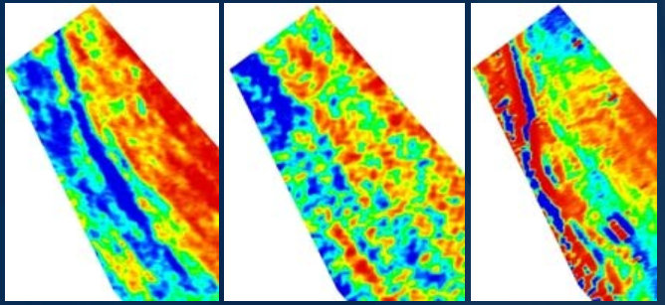
Figure 1: Terraquest’s high quality Max-Gamma™ airborne radiometric survey data showing total count (left), uranium window (middle), and vertical magnetic derivative (right).
The specific results are that:
- Total count data show the structures in the area, running predominantly north-south with a zone of alteration along the right of the image.
- Vertical derivative data (right) show the persistence of interbedded magnetic units to the west of the image with some alteration (orange) as well.
- The middle map is the key map for uranium exploration – it shows directly where the uranium is in the context of nearby structures illustrated by the total count and vertical magnetic derivative results.
For More Information
Terraquest would be pleased to discuss Matrix VLF surveys and interpretation approaches with you, including inversions of existing or planned data. For more information, click here <LINK to EASY-QUOTE form>.

