Case History: Inversion Modelling of Athabasca Uranium-Associated Alteration using Matrix™ VLF-EM
The Athabasca Basin, in Northern Saskatchewan, is host to some of the world’s highest grade uranium mines. With uranium prices starting to rise and exploration interest growing, methods that can add targeting value without requiring excessive budgetary expenditures, can play a key role.
In this example, the geologic model is unconformity style. Here, high grade uranium mineralization located along the unconformity between the basement and overlying sandstones has been remobilized upwards by hydrothermal fluids along steeply dipping faults -- creating resistivity breaches (highs) in the sediments which are characterized by uranium and associated alteration.
Putting Matrix™ VLF into Action for Uranium-Associated Alteration
Terraquest recently performed a Matrix™ VLF-EM case study for uranium exploration in the Athabasca Basin. The purpose of the test was to determine if low-cost, shallow airborne VLF-EM survey techniques can be effective in identifying resistivity breaches. The VLF-EM data were inverted and are shown here compared with drill hole information and a DCIP resistivity profile.
As shown in the figure below, the inversion of airborne Matrix™ VLF-EM in upper panel is at same vertical scale as the coincident inverted DCIP resistivity section. The image shows excellent correlation with the upper reaches of the DCIP resistivity breaches.
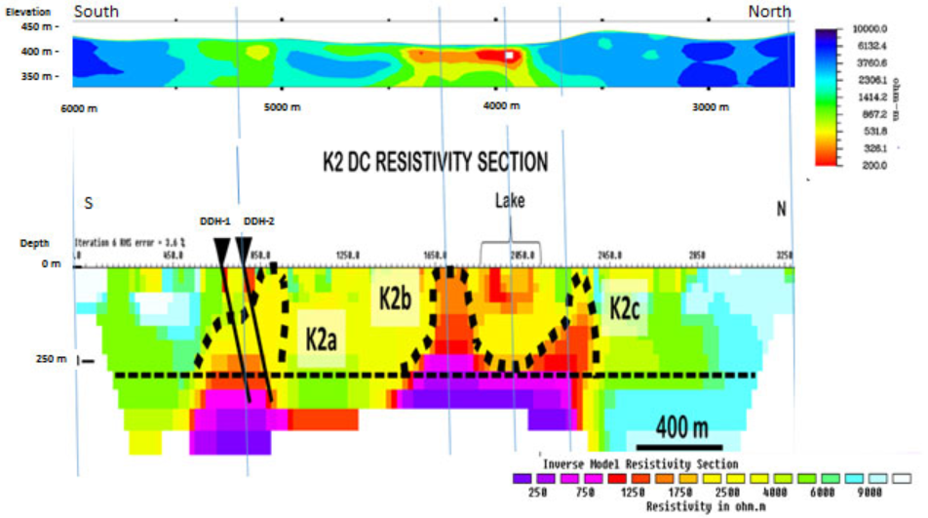
Figure 1: DCIP show a lower resistivity breach is shown to the south and two near surface breaches in the central portion. These are defined in the VLF data and represent low-cost drill targets.
For More Information
Terraquest would be pleased to discuss Matrix™ VLF surveys and interpretation approaches with you, including inversions of existing or planned data. For more information, click here <LINK to EASY-QUOTE form>.

